CHAPTER 9
Biotechnology : Principles and Processes
• Biotechnology : Principles and Processes

U9 | UNIT 9 - BIOTECHNOLOGY : WHY THIS UNIT EXISTS

Since Rene Descartes - the seventeenth-century French philosopher, mathematician and biologist - all human knowledge, and especially the natural sciences, has been directed towards technologies that add to the creature comforts of human lives and add value to human life. The whole approach to understanding natural phenomena thus became anthropocentric. Physics and chemistry gave rise to engineering, technologies and industries which all worked for human comfort and welfare; the major utility of the biological world is as a source of food.
Biotechnology is the twentieth century off-shoot of modern biology. It changed our daily life because its products brought qualitative improvement in health and food production. This unit covers the basic principles underlying biotechnological processes (Chapter 9) and some of their applications (Chapter 10, Biotechnology and Its Applications).
• [Paragraph(
'caseSensitive': 1
'encoding': 'utf8'
'text': 'HERBERT BOYER (1936 - )'
'frags': [ParaFrag(__tag__='b', bold=1, fontName='Times-Bold', fontSize=10.8, greek=0, italic=0, link=[], rise=0, text='HERBERT BOYER (1936 - )', textColor=Color(0,0,0,1), us_lines=[])]
'style': <ParagraphStyle 'Body-Ch13-final'>
'bulletText': None
'debug': 0
) #Paragraph, Paragraph(
'caseSensitive': 1
'encoding': 'utf8'
'text': 'Born 1936, brought up in a corner of western Pennsylvania where railroads and mines were the destiny of most young men. Completed graduate work at the University of Pittsburgh in 1963, followed by three years of post-graduate studies at Yale. In 1966 he took over assistant professorship at the University of California at San Francisco.'
'frags': [ParaFrag(__tag__='para', bold=0, fontName='Times-Roman', fontSize=10.8, greek=0, italic=0, link=[], rise=0, text='Born ', textColor=Color(0,0,0,1), us_lines=[]), ParaFrag(__tag__='b', bold=1, fontName='Times-Bold', fontSize=10.8, greek=0, italic=0, link=[], rise=0, text='1936', textColor=Color(0,0,0,1), us_lines=[]), ParaFrag(__tag__='para', bold=0, fontName='Times-Roman', fontSize=10.8, greek=0, italic=0, link=[], rise=0, text=', brought up in a corner of western Pennsylvania where railroads and mines were the destiny of most young men. Completed graduate work at the University of Pittsburgh in ', textColor=Color(0,0,0,1), us_lines=[]), ParaFrag(__tag__='b', bold=1, fontName='Times-Bold', fontSize=10.8, greek=0, italic=0, link=[], rise=0, text='1963', textColor=Color(0,0,0,1), us_lines=[]), ParaFrag(__tag__='para', bold=0, fontName='Times-Roman', fontSize=10.8, greek=0, italic=0, link=[], rise=0, text=', followed by ', textColor=Color(0,0,0,1), us_lines=[]), ParaFrag(__tag__='b', bold=1, fontName='Times-Bold', fontSize=10.8, greek=0, italic=0, link=[], rise=0, text='three years', textColor=Color(0,0,0,1), us_lines=[]), ParaFrag(__tag__='para', bold=0, fontName='Times-Roman', fontSize=10.8, greek=0, italic=0, link=[], rise=0, text=' of post-graduate studies at Yale. In ', textColor=Color(0,0,0,1), us_lines=[]), ParaFrag(__tag__='b', bold=1, fontName='Times-Bold', fontSize=10.8, greek=0, italic=0, link=[], rise=0, text='1966', textColor=Color(0,0,0,1), us_lines=[]), ParaFrag(__tag__='para', bold=0, fontName='Times-Roman', fontSize=10.8, greek=0, italic=0, link=[], rise=0, text=' he took over assistant professorship at the University of California at San Francisco.', textColor=Color(0,0,0,1), us_lines=[])]
'style': <ParagraphStyle 'Body-Ch13-final'>
'bulletText': None
'debug': 0
) #Paragraph, Paragraph(
'caseSensitive': 1
'encoding': 'utf8'
'text': 'By 1969 he had performed studies on a couple of restriction enzymes of the E. coli bacterium with especially useful properties: these enzymes can cut DNA strands in a particular fashion, leaving what became known as sticky ends on the strands. These clipped ends made pasting together pieces of DNA a precise exercise.'
'frags': [ParaFrag(__tag__='para', bold=0, fontName='Times-Roman', fontSize=10.8, greek=0, italic=0, link=[], rise=0, text='By ', textColor=Color(0,0,0,1), us_lines=[]), ParaFrag(__tag__='b', bold=1, fontName='Times-Bold', fontSize=10.8, greek=0, italic=0, link=[], rise=0, text='1969', textColor=Color(0,0,0,1), us_lines=[]), ParaFrag(__tag__='para', bold=0, fontName='Times-Roman', fontSize=10.8, greek=0, italic=0, link=[], rise=0, text=' he had performed studies on a couple of ', textColor=Color(0,0,0,1), us_lines=[]), ParaFrag(__tag__='b', bold=1, fontName='Times-Bold', fontSize=10.8, greek=0, italic=0, link=[], rise=0, text='restriction enzymes', textColor=Color(0,0,0,1), us_lines=[]), ParaFrag(__tag__='para', bold=0, fontName='Times-Roman', fontSize=10.8, greek=0, italic=0, link=[], rise=0, text=' of the ', textColor=Color(0,0,0,1), us_lines=[]), ParaFrag(__tag__='i', bold=0, fontName='Times-Italic', fontSize=10.8, greek=0, italic=1, link=[], rise=0, text='E. coli', textColor=Color(0,0,0,1), us_lines=[]), ParaFrag(__tag__='para', bold=0, fontName='Times-Roman', fontSize=10.8, greek=0, italic=0, link=[], rise=0, text=' bacterium with especially useful properties: these enzymes can cut DNA strands in a particular fashion, leaving what became known as ', textColor=Color(0,0,0,1), us_lines=[]), ParaFrag(__tag__='b', bold=1, fontName='Times-Bold', fontSize=10.8, greek=0, italic=0, link=[], rise=0, text='sticky ends', textColor=Color(0,0,0,1), us_lines=[]), ParaFrag(__tag__='para', bold=0, fontName='Times-Roman', fontSize=10.8, greek=0, italic=0, link=[], rise=0, text=' on the strands. These clipped ends made pasting together pieces of DNA a precise exercise.', textColor=Color(0,0,0,1), us_lines=[])]
'style': <ParagraphStyle 'Body-Ch13-final'>
'bulletText': None
'debug': 0
) #Paragraph, Paragraph(
'caseSensitive': 1
'encoding': 'utf8'
'text': 'That discovery led to a rich and rewarding conversation in Hawaii with a Stanford scientist, Stanley Cohen. Cohen had been studying small ringlets of DNA called plasmids, which float about freely in the cytoplasm of certain bacterial cells and replicate independently from the coding strand of DNA; he had developed a method of removing these plasmids from the cell and then reinserting them in other cells. Combining this with DNA splicing let Boyer and Cohen recombine segments of DNA in desired configurations and insert the DNA into bacterial cells, which could then act as manufacturing plants for specific proteins. This breakthrough was the basis upon which the discipline of biotechnology was founded.'
'frags': [ParaFrag(__tag__='para', bold=0, fontName='Times-Roman', fontSize=10.8, greek=0, italic=0, link=[], rise=0, text='That discovery led to a rich and rewarding conversation in Hawaii with a Stanford scientist, ', textColor=Color(0,0,0,1), us_lines=[]), ParaFrag(__tag__='b', bold=1, fontName='Times-Bold', fontSize=10.8, greek=0, italic=0, link=[], rise=0, text='Stanley Cohen', textColor=Color(0,0,0,1), us_lines=[]), ParaFrag(__tag__='para', bold=0, fontName='Times-Roman', fontSize=10.8, greek=0, italic=0, link=[], rise=0, text='. Cohen had been studying small ringlets of DNA called ', textColor=Color(0,0,0,1), us_lines=[]), ParaFrag(__tag__='b', bold=1, fontName='Times-Bold', fontSize=10.8, greek=0, italic=0, link=[], rise=0, text='plasmids', textColor=Color(0,0,0,1), us_lines=[]), ParaFrag(__tag__='para', bold=0, fontName='Times-Roman', fontSize=10.8, greek=0, italic=0, link=[], rise=0, text=', which float about freely in the cytoplasm of certain bacterial cells and replicate independently from the coding strand of DNA; he had developed a method of removing these plasmids from the cell and then reinserting them in other cells. Combining this with DNA splicing let Boyer and Cohen recombine segments of DNA in desired configurations and insert the DNA into bacterial cells, which could then act as manufacturing plants for specific proteins. This breakthrough was the basis upon which the discipline of biotechnology was founded.', textColor=Color(0,0,0,1), us_lines=[])]
'style': <ParagraphStyle 'Body-Ch13-final'>
'bulletText': None
'debug': 0
) #Paragraph]
9 | WHAT BIOTECHNOLOGY MEANS

• Biotechnology deals with the techniques of using live organisms, or enzymes from organisms, to produce products and processes useful to humans. Taken together with the chapter summary, it also covers the large scale production and marketing of products and processes using live organisms, cells or enzymes.
In that broad sense, making curd, bread or wine - all microbe-mediated processes - could also be thought of as a form of biotechnology. However, the word is used in a restricted sense today: it refers to those processes which use genetically modified organisms to achieve the same on a larger scale. Further, many other processes and techniques are also included under biotechnology - for example in vitro fertilisation leading to a 'test-tube' baby, synthesising a gene and using it, developing a DNA vaccine, or correcting a defective gene: all of these are part of biotechnology.
• The European Federation of Biotechnology (EFB) definition deliberately encompasses both the traditional view and modern molecular biotechnology: 'The integration of natural science and organisms, cells, parts thereof, and molecular analogues for products and services'.
9.1 | PRINCIPLES OF BIOTECHNOLOGY

Among many techniques, two core techniques enabled the birth of modern biotechnology.
Core technique | What it is
(i) Genetic engineering | Techniques to alter the chemistry of genetic material (DNA and RNA), to introduce these into host organisms, and thus change the phenotype of the host organism.
(ii) Bioprocess engineering | Maintenance of sterile (microbial contamination-free) ambience in chemical engineering processes, to enable growth of only the desired microbe / eukaryotic cell in large quantities for the manufacture of biotechnological products like antibiotics, vaccines, enzymes, etc.

9.1 | Why genetic engineering was needed

Sexual reproduction provides opportunities for variations and for the formulation of unique combinations of genetic setup, some of which may be beneficial to the organism as well as to the population.
Mode of reproduction | What it does to genetic information
Asexual reproduction | Preserves the genetic information.
Sexual reproduction | Permits variation.

Traditional hybridisation procedures used in plant and animal breeding very often lead to inclusion and multiplication of undesirable genes along with the desired genes. The techniques of genetic engineering - which include creation of recombinant DNA, use of gene cloning and gene transfer - overcome this limitation and allow us to isolate and introduce only one or a set of desirable genes without introducing undesirable genes into the target organism.
9.1 | Fate of an alien piece of DNA: the origin of replication

What happens to a piece of DNA that is somehow transferred into an alien organism? Most likely, this piece of DNA would not be able to multiply itself in the progeny cells of the organism. But when it gets integrated into the genome of the recipient, it may multiply and be inherited along with the host DNA - because the alien piece of DNA has become part of a chromosome, which has the ability to replicate.
• In a chromosome there is a specific DNA sequence called the origin of replication, which is responsible for initiating replication. Therefore, for the multiplication of any alien piece of DNA in an organism, it needs to be a part of a chromosome(s) which has this specific sequence. An alien DNA is thus linked with the origin of replication so that it can replicate and multiply itself in the host organism.
• This can also be called cloning: making multiple identical copies of any template DNA.
9.1 | The first artificial recombinant DNA molecule (1972)

The construction of the first recombinant DNA emerged from the possibility of linking a gene encoding antibiotic resistance with a native plasmid (autonomously replicating circular extra-chromosomal DNA) of Salmonella typhimurium. Stanley Cohen and Herbert Boyer accomplished this in 1972.
1 | Isolate the antibiotic resistance gene by cutting out a piece of DNA from a plasmid which was responsible for conferring antibiotic resistance. Cutting DNA at specific locations became possible with the discovery of the so-called 'molecular scissors' - restriction enzymes.
2 | Link the cut piece of DNA with the plasmid DNA. These plasmid DNA act as vectors to transfer the piece of DNA attached to them - just as a mosquito acts as an insect vector to transfer the malarial parasite into the human body.
3 | Join the ends with the enzyme DNA ligase, which acts on cut DNA molecules and joins their ends. This makes a new combination of circular autonomously replicating DNA created in vitro, known as recombinant DNA.
4 | Transfer this DNA into Escherichia coli, a bacterium closely related to Salmonella. It could replicate using the new host's DNA polymerase enzyme and make multiple copies. This ability to multiply copies of the antibiotic resistance gene in E. coli was called cloning of the antibiotic resistance gene in E. coli.

9.1 | The three basic steps in genetically modifying an organism

1 | Identification of DNA with desirable genes.
2 | Introduction of the identified DNA into the host.
3 | Maintenance of introduced DNA in the host, and transfer of the DNA to its progeny.

[MEMORY AID - not in NCERT] The whole chapter is one sentence: CUT - PASTE - CARRY - COPY - HARVEST. Cut (restriction enzyme), paste (ligase), carry (vector into a competent host), copy (origin of replication / PCR), harvest (bioreactor then downstream processing).

9.2 | TOOLS OF RECOMBINANT DNA TECHNOLOGY

Genetic engineering (recombinant DNA technology) can be accomplished only if we have the key tools. There are five: restriction enzymes, polymerase enzymes, ligases, vectors and the host organism.
9.2.1 | Restriction Enzymes

The discovery ran in two stages, five years apart.
Year | What was found | Significance
1963 | The two enzymes responsible for restricting the growth of bacteriophage in Escherichia coli were isolated. One added methyl groups to DNA; the other cut DNA. | The cutting enzyme was called restriction endonuclease.
Five years later (i.e. after 1963) | The first restriction endonuclease - Hind II - whose functioning depended on a specific DNA nucleotide sequence, was isolated and characterised. | Hind II always cuts DNA at a particular point by recognising a specific sequence of six base pairs. That sequence is its recognition sequence.
Today | More than 900 restriction enzymes are known, isolated from over 230 strains of bacteria. | Each recognises a different recognition sequence.

9.2.1 | How restriction enzymes are named

The name is not arbitrary - every part of EcoRI is readable:
Part of the name | Where it comes from | In EcoRI
First letter | The genus of the prokaryotic cell it was isolated from | E = Escherichia
Second two letters | The species | co = coli
Following letter(s) | The name of the strain | R = from strain RY 13
Roman number | The order in which the enzymes were isolated from that strain of bacteria | I = the first isolated

9.2.1 | Where restriction enzymes sit among the nucleases

Restriction enzymes belong to a larger class of enzymes called nucleases. These are of two kinds.
Kind of nuclease | Where it cuts
Exonucleases | Remove nucleotides from the ends of the DNA.
Endonucleases | Make cuts at specific positions within the DNA.

9.2.1 | How a restriction endonuclease works

1 | Inspect - each restriction endonuclease functions by 'inspecting' the length of a DNA sequence.
2 | Bind - once it finds its specific recognition sequence, it binds to the DNA.
3 | Cut - it cuts each of the two strands of the double helix at specific points in their sugar-phosphate backbones.

• Each restriction endonuclease recognises a specific palindromic nucleotide sequence in the DNA. A palindrome is a group of letters that forms the same word read both forward and backward, e.g. 'MALAYALAM'. But note the difference: in a word-palindrome the same word is read in both directions, whereas the palindrome in DNA is a sequence of base pairs that reads the same on the two strands when the orientation of reading is kept the same.
For example, the following sequence reads the same on the two strands in the 5' to 3' direction - and this is also true if read in the 3' to 5' direction:
Strand | Sequence
5' --- | G A A T T C --- 3'
3' --- | C T T A A G --- 5'

9.2.1 | Sticky ends - why the cut is off-centre

Restriction enzymes cut the strand of DNA a little away from the centre of the palindrome sites, but between the same two bases on the opposite strands. This leaves single stranded portions at the ends - overhanging stretches called sticky ends on each strand.
• They are named sticky because they form hydrogen bonds with their complementary cut counterparts. This stickiness of the ends facilitates the action of the enzyme DNA ligase.
Restriction endonucleases are therefore used in genetic engineering to form 'recombinant' molecules of DNA, which are composed of DNA from different sources/genomes. When cut by the same restriction enzyme, the resultant DNA fragments have the same kind of sticky ends, and these can be joined together (end-to-end) using DNA ligases.
[NOTE] Normally, unless one cuts the vector and the source DNA with the same restriction enzyme, the recombinant vector molecule cannot be created.

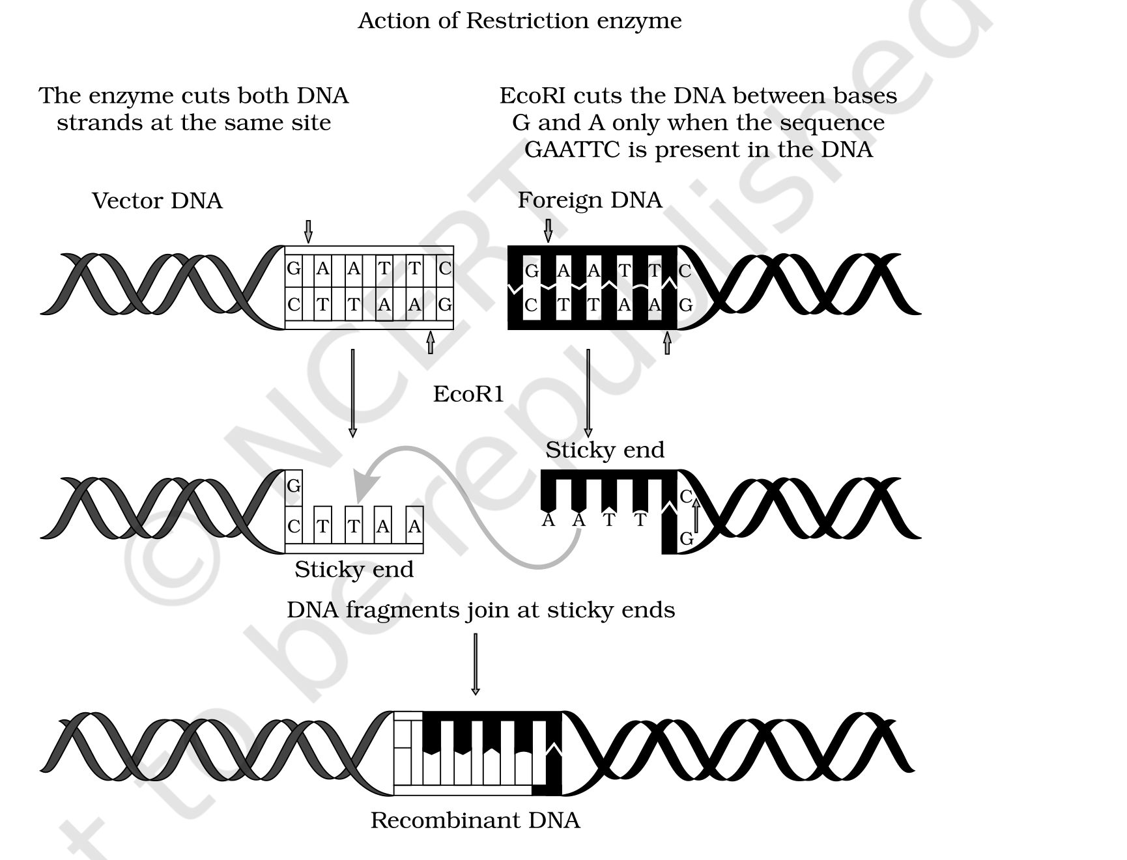
Fig. 9.1 - Steps in formation of recombinant DNA by action of restriction endonuclease enzyme - EcoRI. The enzyme cuts both DNA strands at the same site, cutting between bases G and A only where the sequence GAATTC is present, so that the vector DNA and the foreign DNA both end in matching sticky ends and can join to give recombinant DNA. The original is colour-coded; here the vector DNA is the outline strand and the foreign DNA the solid black strand.
9.2.1 | Separation and isolation of DNA fragments

Cutting DNA with restriction endonucleases results in fragments of DNA. These fragments are separated by a technique known as gel electrophoresis.
1 | Move them in a field - since DNA fragments are negatively charged molecules, they are separated by forcing them to move towards the anode under an electric field through a medium/matrix.
2 | Sieve them by size - the most commonly used matrix nowadays is agarose, a natural polymer extracted from sea weeds. The fragments separate (resolve) according to their size through the sieving effect provided by the agarose gel. Hence the smaller the fragment size, the farther it moves.
3 | Stain and view - the separated fragments can be visualised only after staining the DNA with ethidium bromide followed by exposure to UV radiation. You cannot see pure DNA fragments in visible light without staining. You then see bright orange coloured bands of DNA.
4 | Cut out and elute - the separated bands of DNA are cut out from the agarose gel and extracted from the gel piece. This step is known as elution.

The DNA fragments purified in this way are used in constructing recombinant DNA by joining them with cloning vectors.
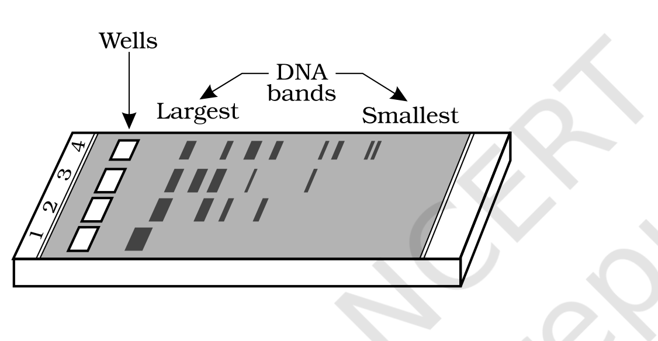
Fig. 9.3 - A typical agarose gel electrophoresis showing migration of undigested DNA (lane 1) and digested sets of DNA fragments (lanes 2 to 4). The largest fragments stay nearest the wells and the smallest travel farthest.
[MEMORY AID - not in NCERT] Gel electrophoresis in one line: negative DNA runs to the positive anode, small runs fast. Then stain (ethidium bromide) - shine (UV) - see (orange bands) - snip (elution).

9.2.2 | Cloning Vectors

Plasmids and bacteriophages have the ability to replicate within bacterial cells independent of the control of chromosomal DNA. That independence is what makes them useful as vectors.
Vector | Copy number within the bacterial cell
Bacteriophages | Because of their high number per cell, they have very high copy numbers of their genome within the bacterial cells.
Plasmids | Some may have only one or two copies per cell, whereas others may have 15-100 copies per cell. Their numbers can go even higher.

So if we can link an alien piece of DNA with bacteriophage or plasmid DNA, we can multiply its numbers equal to the copy number of the plasmid or bacteriophage.
Vectors used at present are engineered in such a way that they help (a) easy linking of foreign DNA and (b) selection of recombinants from non-recombinants. Four engineered features do this work.
9.2.2 | Feature 1 - Origin of replication (ori)

• Origin of replication (ori) is a sequence from where replication starts, and any piece of DNA when linked to this sequence can be made to replicate within the host cells. This sequence is also responsible for controlling the copy number of the linked DNA.
[NOTE] Practical consequence: if one wants to recover many copies of the target DNA, it should be cloned in a vector whose origin supports high copy number.

9.2.2 | Feature 2 - Selectable marker

• In addition to 'ori', the vector requires a selectable marker, which helps in identifying and eliminating non-transformants and selectively permitting the growth of the transformants.
• Transformation is a procedure through which a piece of DNA is introduced in a host bacterium.
Normally the genes encoding resistance to antibiotics such as ampicillin, chloramphenicol, tetracycline or kanamycin are considered useful selectable markers for E. coli. This works because normal E. coli cells do not carry resistance against any of these antibiotics.
9.2.2 | Feature 3 - Cloning sites

In order to link the alien DNA, the vector needs to have very few, preferably single, recognition sites for the commonly used restriction enzymes. Presence of more than one recognition site within the vector will generate several fragments, which will complicate the gene cloning.
The ligation of alien DNA is carried out at a restriction site present in one of the two antibiotic resistance genes. For example, you can ligate a foreign DNA at the BamH I site of the tetracycline resistance gene in the vector pBR322. The recombinant plasmids will lose tetracycline resistance due to insertion of foreign DNA, but can still be selected out from non-recombinant ones by plating the transformants on ampicillin containing medium.
1 | Plate the transformants on ampicillin containing medium.
2 | Transfer the transformants growing on ampicillin medium onto a medium containing tetracycline.
3 | Read the result: the recombinants will grow in ampicillin containing medium but not on tetracycline. The non-recombinants will grow on the medium containing both the antibiotics.

In this case one antibiotic resistance gene helps in selecting the transformants, whereas the other antibiotic resistance gene gets 'inactivated due to insertion' of alien DNA and helps in selection of recombinants.
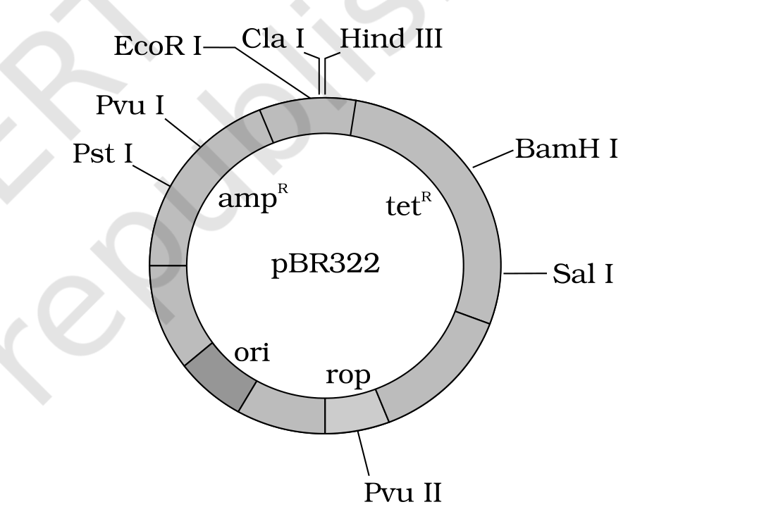
Fig. 9.4 - E. coli cloning vector pBR322 showing restriction sites (Hind III, EcoR I, BamH I, Sal I, Pvu II, Pst I, Cla I), ori, and the antibiotic resistance genes amp^{R} and tet^{R}. rop codes for the proteins involved in the replication of the plasmid. The original distinguishes the amp^{R}, tet^{R}, ori and rop arcs by colour; in this monochrome print each region is identified by its printed label, and the arcs are separated by the boundary lines at the restriction sites.
9.2.2 | A better marker - insertional inactivation with a colour readout

Selection of recombinants due to inactivation of antibiotics is a cumbersome procedure, because it requires simultaneous plating on two plates having different antibiotics. Therefore alternative selectable markers have been developed which differentiate recombinants from non-recombinants on the basis of their ability to produce colour in the presence of a chromogenic substrate.
1 | A recombinant DNA is inserted within the coding sequence of an enzyme, beta-galactosidase.
2 | This results in inactivation of the gene for synthesis of this enzyme - referred to as insertional inactivation.
3 | Read the colour on a chromogenic substrate: blue coloured colonies mean the plasmid in the bacteria does not have an insert; colonies that do not produce any colour have suffered insertional inactivation of the beta-galactosidase gene and are identified as recombinant colonies.

9.2.2 | Vectors for cloning genes in plants and animals

Here biotechnologists borrowed from natural pathogens, which have always transferred genes into eukaryotic hosts.
Natural agent | What it does in nature | How it was turned into a vector
Agrobacterium tumifaciens, a pathogen of several dicot plants | Delivers a piece of DNA known as 'T-DNA' to transform normal plant cells into a tumor, and directs these tumor cells to produce the chemicals required by the pathogen. | Its tumor inducing (Ti) plasmid has been modified into a cloning vector which is no more pathogenic to the plants but is still able to use the mechanisms to deliver genes of our interest into a variety of plants.
Retroviruses in animals | Have the ability to transform normal cells into cancerous cells. | Have also been disarmed and are now used to deliver desirable genes into animal cells.

Once a gene or a DNA fragment has been ligated into a suitable vector, it is transferred into a bacterial, plant or animal host, where it multiplies.
9.2.3 | Competent Host (for transformation with recombinant DNA)

The obstacle is chemical: since DNA is a hydrophilic molecule, it cannot pass through cell membranes. So the host has to be forced to take it up.
1 | Make the cells competent - in order to force bacteria to take up the plasmid, the bacterial cells must first be made 'competent' to take up DNA. This is done by treating them with a specific concentration of a divalent cation, such as calcium, which increases the efficiency with which DNA enters the bacterium through pores in its cell wall.
2 | Incubate on ice with the recombinant DNA.
3 | Heat shock - place them briefly at 42 degrees C.
4 | Return to ice - this enables the bacteria to take up the recombinant DNA.

9.2.3 | Three other ways to get DNA into a cell

Method | How it works | Suited to
Micro-injection | Recombinant DNA is directly injected into the nucleus. | Animal cells
Biolistics or gene gun | Cells are bombarded with high velocity micro-particles of gold or tungsten coated with DNA. | Plants
'Disarmed pathogen' vectors | When allowed to infect the cell, they transfer the recombinant DNA into the host. | Plant and animal cells

[MEMORY AID - not in NCERT] Four doors into a cell: C - M - G - P. Calcium-competent heat shock (bacteria), Micro-injection (animal), Gene gun / biolistics (plant), Pathogen disarmed (both).

9.3 | PROCESSES OF RECOMBINANT DNA TECHNOLOGY

Recombinant DNA technology involves several steps in a specific sequence. The whole chapter's machinery is now assembled in order.
1 | Isolation of DNA.
2 | Fragmentation of DNA by restriction endonucleases.
3 | Isolation of a desired DNA fragment.
4 | Ligation of the DNA fragment into a vector.
5 | Transferring the recombinant DNA into the host.
6 | Culturing the host cells in a medium at large scale.
7 | Extraction of the desired product.

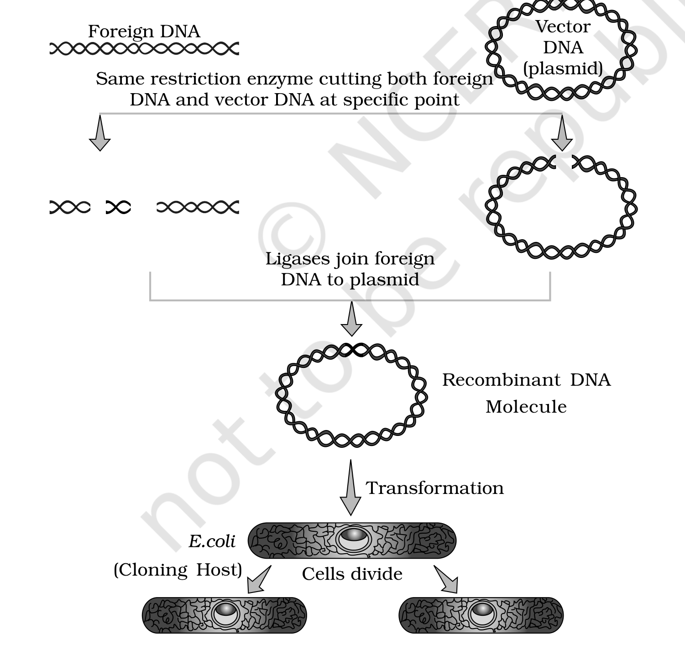
Fig. 9.2 - Diagrammatic representation of recombinant DNA technology: the same restriction enzyme cuts both foreign DNA and vector DNA (plasmid) at a specific point, ligases join the foreign DNA to the plasmid to give the recombinant DNA molecule, transformation carries it into E. coli (the cloning host), and the cells then divide - each daughter cell carrying the recombinant DNA.
9.3.1 | Isolation of the Genetic Material (DNA)

Recall that nucleic acid is the genetic material of all organisms without exception, and in the majority of organisms this is deoxyribonucleic acid (DNA). In order to cut the DNA with restriction enzymes, it needs to be in pure form, free from other macro-molecules.
1 | Break the cell open - since the DNA is enclosed within the membranes, the cell must be broken open to release DNA along with other macromolecules such as RNA, proteins, polysaccharides and also lipids. This is done by treating the bacterial cells / plant or animal tissue with enzymes: lysozyme (bacteria), cellulase (plant cells), chitinase (fungus).
2 | Free the DNA from its protein packing - genes are located on long molecules of DNA interwined with proteins such as histones.
3 | Strip away RNA and protein - the RNA can be removed by treatment with ribonuclease, whereas proteins can be removed by treatment with protease. Other molecules can be removed by appropriate treatments.
4 | Precipitate the DNA - purified DNA ultimately precipitates out after the addition of chilled ethanol. This can be seen as a collection of fine threads in the suspension.

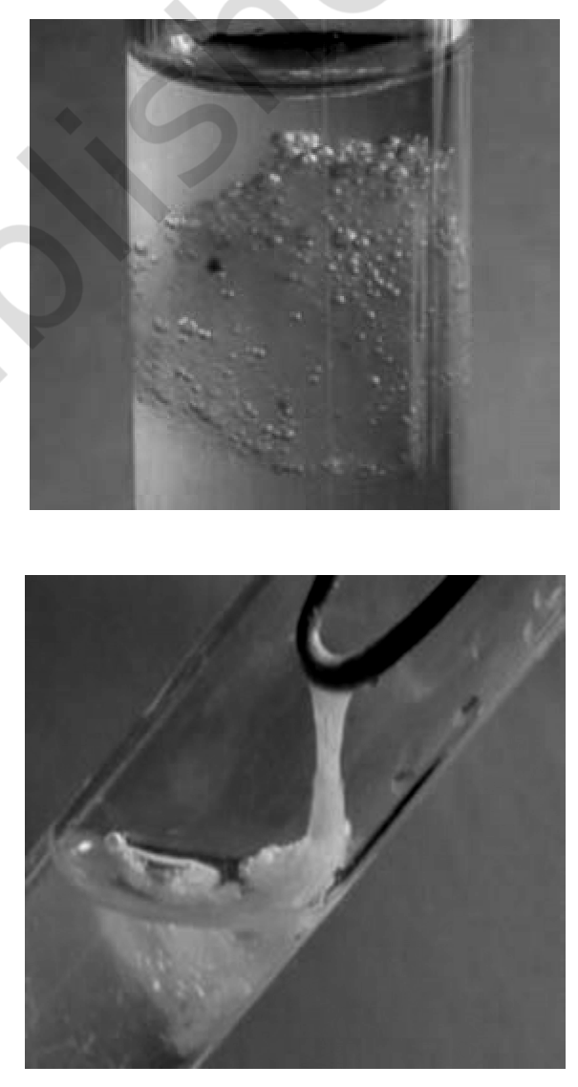
Fig. 9.5 - DNA that separates out can be removed by spooling. The precipitated DNA appears as a collection of fine threads in the suspension.
9.3.2 | Cutting of DNA at Specific Locations

1 | Digest - restriction enzyme digestions are performed by incubating purified DNA molecules with the restriction enzyme, at the optimal conditions for that specific enzyme.
2 | Check the progress - agarose gel electrophoresis is employed to check the progression of a restriction enzyme digestion. DNA is a negatively charged molecule, hence it moves towards the positive electrode (anode).
3 | Repeat with the vector - the process is repeated with the vector DNA also.
4 | Mix and ligate - after having cut the source DNA as well as the vector DNA with a specific restriction enzyme, the cut out 'gene of interest' from the source DNA and the cut vector with space are mixed and ligase is added. This results in the preparation of recombinant DNA.

9.3.3 | Amplification of Gene of Interest Using PCR

• PCR stands for Polymerase Chain Reaction. In this reaction, multiple copies of the gene (or DNA) of interest are synthesised in vitro using two sets of primers - small chemically synthesised oligonucleotides that are complementary to the regions of DNA - and the enzyme DNA polymerase.
The enzyme extends the primers using the nucleotides provided in the reaction and the genomic DNA as template. If the process of replication of DNA is repeated many times, the segment of DNA can be amplified to approximately a billion times, i.e. 1 billion copies are made.
1 | (cycle - last step feeds back to step 1)
2 | Denaturation - the double stranded DNA is separated by heat.
3 | Primer annealing - the two sets of primers bind to their complementary regions.
4 | Extension of primers - DNA polymerase (Taq polymerase) + deoxynucleotides extend the primers.

[NOTE] The enzyme used is a thermostable DNA polymerase isolated from the bacterium Thermus aquaticus, which remains active during the high temperature induced denaturation of double stranded DNA. That heat-stability is precisely why the cycle can be repeated without adding fresh enzyme.

The template is the ds DNA (double stranded DNA). Only the region to be amplified - the stretch flanked by the two primer binding sites - is copied; the flanking DNA on either side is not. Each strand is antiparallel, so every strand end carries a polarity label: the strand that reads 5' to 3' left to right is paired with one that reads 3' to 5'. Each primer is likewise labelled 5' and 3' and anneals in the orientation opposite to the strand it binds, so the polymerase extends the two primers in opposite directions along the two template strands.
9.3.3 | Reading one PCR cycle, step by step

Step | What is done to the DNA | What drives it
Denaturation | The ds DNA is separated into its two single strands. | Heat.
Primer annealing | The two sets of primers bind to their complementary regions, one on each separated strand, bracketing the region to be amplified. | Primers - chemically synthesised oligonucleotides.
Extension of primers | The bound primers are extended along the template, copying the region to be amplified and restoring two double stranded molecules. | DNA polymerase (Taq polymerase) + deoxynucleotides.
Repeat the cycle | The products become templates for the next round, so copy number doubles each cycle. | 30 cycles, giving DNA amplified about 1 billion times.

The amplified fragment, if desired, can now be used to ligate with a vector for further cloning.
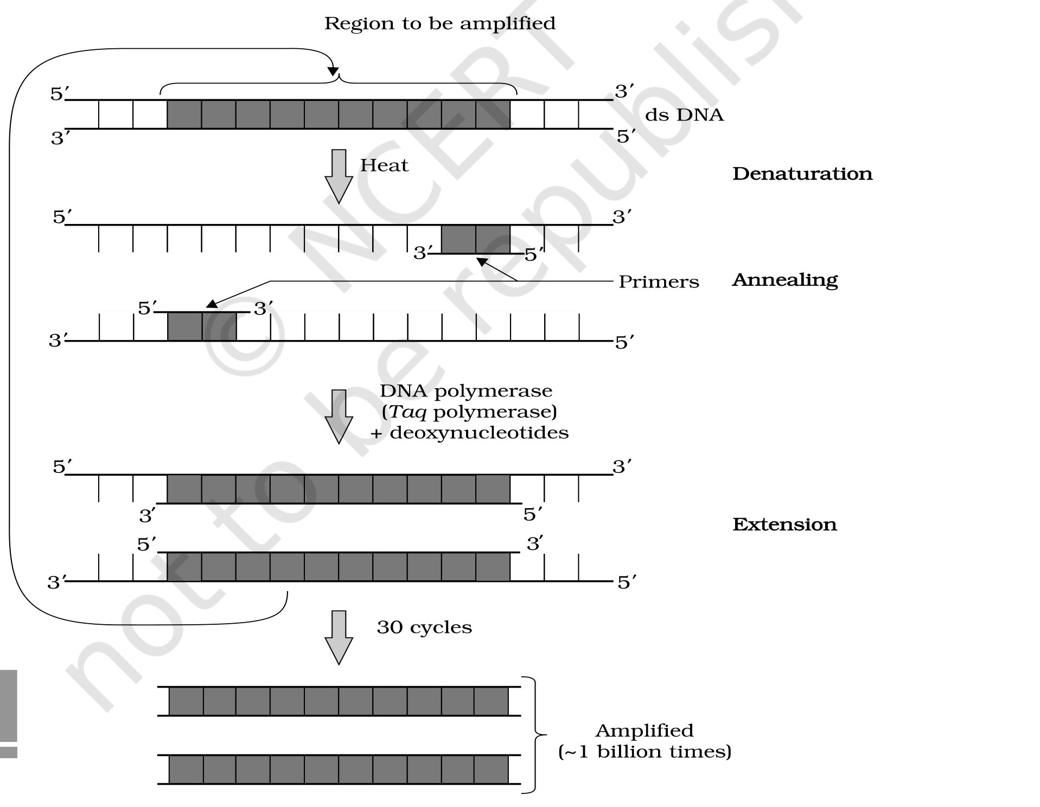
Fig. 9.6 - Polymerase chain reaction (PCR). Each cycle has three steps: (i) Denaturation; (ii) Primer annealing; and (iii) Extension of primers. Run for 30 cycles, the region to be amplified is amplified about 1 billion times. The shaded blocks mark the region being amplified; the outline blocks are the flanking DNA that is not.
[MEMORY AID - not in NCERT] PCR = D - A - E, thirty times over: Denature (heat splits the strands), Anneal (primers land), Extend (Taq builds). Heat is the reason Thermus aquaticus is in the tube at all.

9.3.4 | Insertion of Recombinant DNA into the Host Cell / Organism

Recipient cells, after making them 'competent' to receive, take up DNA present in their surroundings. The selection then does the sorting for us.
1 | Transfer a recombinant DNA bearing a gene for resistance to an antibiotic (e.g. ampicillin) into E. coli cells - the host cells become ampicillin-resistant cells.
2 | Spread the transformed cells on agar plates containing ampicillin.
3 | Read the plate: only transformants will grow; untransformed recipient cells will die.

• The ampicillin resistance gene in this case is called a selectable marker.
9.3.5 | Obtaining the Foreign Gene Product

When you insert a piece of alien DNA into a cloning vector and transfer it into a bacterial, plant or animal cell, the alien DNA gets multiplied. But in almost all recombinant technologies the ultimate aim is to produce a desirable protein. Hence there is a need for the recombinant DNA to be expressed - the foreign gene gets expressed under appropriate conditions.
• If any protein encoding gene is expressed in a heterologous host, it is called a recombinant protein.
9.3.5 | From small scale to large scale

Scale | How it is run | What it yields
Small scale (laboratory) | The cells harbouring cloned genes of interest may be grown on a small scale in the laboratory. The cultures may be used for extracting the desired protein and then purifying it by using different separation techniques. | Small volume cultures cannot yield appreciable quantities of products.
Continuous culture system | The used medium is drained out from one side while fresh medium is added from the other, to maintain the cells in their physiologically most active log / exponential phase. | Produces a larger biomass, leading to higher yields of desired protein.
Bioreactors | Large volumes of 100-1000 litres of culture can be processed. | The industrial scale needed once small volumes proved insufficient.

• Bioreactors can be thought of as vessels in which raw materials are biologically converted into specific products, individual enzymes, etc., using microbial, plant, animal or human cells. A bioreactor provides the optimal conditions for achieving the desired product by providing optimum growth conditions - temperature, pH, substrate, salts, vitamins, oxygen.
The most commonly used bioreactors are of stirring type. A stirred-tank reactor is usually cylindrical or with a curved base to facilitate the mixing of the reactor contents. The stirrer facilitates even mixing and oxygen availability throughout the bioreactor. Alternatively, air can be bubbled through the reactor.
9.3.5 | What a stirred-tank bioreactor must have

System | Its job | The part that does it
Agitator system | Even mixing of the reactor contents. | A motor on top driving a flat bladed impeller down in the culture broth.
Oxygen delivery system | Oxygen availability throughout the bioreactor. | A sterile air inlet.
Foam control system | Controls the foam that agitation throws up. | A foam breaker, mounted on the same shaft above the broth.
Temperature control system | Holds the optimum temperature. | A jacket / coil around the vessel; steam is also piped in for sterilisation.
pH control system | Holds the optimum pH. | An acid line and a base line into the vessel.
Sampling ports | So that small volumes of the culture can be withdrawn periodically. | A sampling port in the vessel wall.

In the sparged stirred-tank variant, sterile air is sparged (blown in as fine bubbles) from the base. This gives an increased surface area for oxygen transfer plus gas entrainment, because the bubbles dramatically increase the oxygen transfer area.
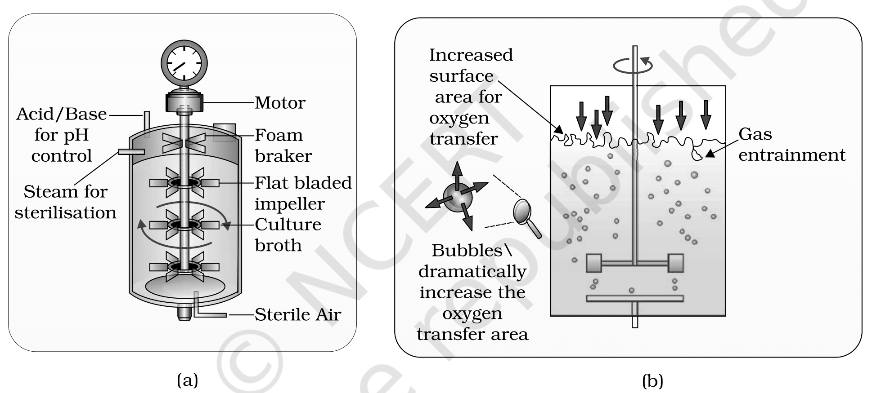
Fig. 9.7 - (a) Simple stirred-tank bioreactor, showing the motor, foam breaker, flat bladed impeller, culture broth, sterile air inlet, acid/base line for pH control and steam for sterilisation; (b) Sparged stirred-tank bioreactor through which sterile air bubbles are sparged - giving increased surface area for oxygen transfer and gas entrainment, because the bubbles dramatically increase the oxygen transfer area.
9.3.6 | Downstream Processing

After completion of the biosynthetic stage, the product has to be subjected to a series of processes before it is ready for marketing as a finished product.
• The processes include separation and purification, which are collectively referred to as downstream processing.
1 | Separation and purification of the product.
2 | Formulation - the product has to be formulated with suitable preservatives.
3 | Clinical trials - such formulation has to undergo thorough clinical trials as in the case of drugs.
4 | Quality control - strict quality control testing for each product is also required.

[NOTE] The downstream processing and quality control testing vary from product to product - there is no single fixed protocol to memorise here.

R | QUICK RECAP

1 | Biotechnology deals with large scale production and marketing of products and processes using live organisms, cells or enzymes.
2 | Modern biotechnology using genetically modified organisms was made possible only when man learnt to alter the chemistry of DNA and construct recombinant DNA. This key process is called recombinant DNA technology or genetic engineering.
3 | The process involves the use of restriction endonucleases, DNA ligase, and appropriate plasmid or viral vectors to isolate and ferry the foreign DNA into host organisms.
4 | Then comes expression of the foreign gene, purification of the gene product (i.e. the functional protein), and finally making a suitable formulation for marketing.
5 | Large scale production involves use of bioreactors.

A | APPENDIX - WHAT THE NCERT EXERCISES ASSUME

Every exercise question is either answerable from the sections above, or it is not answerable from this chapter at all. Both cases are stated plainly - no outside facts have been introduced to paper over a gap.
Exercise asks about | Status | Where it is covered / why it is not
Recombinant proteins used in medical practice (list of 10) | Beyond this chapter | The chapter defines a recombinant protein (9.3.5) but supplies no list. The exercise directs you to an internet search, so no list is invented here.
Restriction enzyme, its substrate DNA, cut site and product | Covered | 9.2.1 (mechanism, palindromes, sticky ends) and Fig. 9.1.
Relative molecular size of enzymes vs DNA | Beyond this chapter | The chapter gives no molecular sizes. It is a reasoning exercise; no figure has been invented to fill it.
Molar concentration of human DNA in a human cell | Beyond this chapter | No data given anywhere in the chapter; the exercise itself says 'Consult your teacher'.
Do eukaryotic cells have restriction endonucleases? | Reason from the chapter | 9.2.1 states the enzymes were isolated from bacteria (over 230 strains) and that their natural role is restricting bacteriophage growth - reason from those two facts only.
Advantages of stirred tank bioreactors over shake flasks | Covered | 9.3.5 - the 100-1000 litre volume plus the six control systems (agitator, oxygen, foam, temperature, pH, sampling ports).
Palindromic DNA sequences | Covered | 9.2.1 - the definition, the MALAYALAM analogy, and the GAATTC / CTTAAG pair.
Meiosis stage at which a recombinant DNA is made | Beyond this chapter | Recombination / crossing over is not covered here; it belongs to the inheritance chapters.
A reporter enzyme to monitor transformation alongside a selectable marker | Covered | 9.2.2 - the beta-galactosidase insertional-inactivation and chromogenic-substrate colour readout is exactly this.
ori; bioreactors; downstream processing; PCR; restriction enzymes; chitinase; plasmid vs chromosomal DNA; RNA vs DNA; exonuclease vs endonuclease | All covered | 9.1 and 9.2.2 (ori), 9.3.5 (bioreactors), 9.3.6 (downstream), 9.3.3 (PCR), 9.2.1 (restriction enzymes, exo vs endo), 9.3.1 (chitinase, nucleic acid), 9.1 / 9.2.2 (plasmid).

[NOTE] Source problems noted during extraction. Page-number artifacts bleed into the extracted text of the source PDF (e.g. "others may have 168 15-100 copies per cell" on page 8, and "117722" on page 12). Checked against the rendered page images: the true values are 15-100 copies per cell and page number 172. No content is missing. The unit-opening page also interleaves the Unit 9 introduction with the chapter-list sidebar, so that text was reconstructed from the rendered page image.

